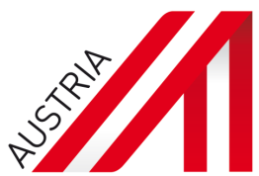

We are looking for 2 interns for our advanced material project with a conference which will be held on 22. Jan. 2016.
Requirements:
- Major in materials
- Good knowledge of English
- Interest in event organization and logistics
- Available full time for at least one month during December 2015 and January 2016
- Good at establishing new contacts and cold-calling for B2B meetings
- Broad knowledge or interest for advanced materials research outside his/her own research area
- Well-organized and open personality

Salary will be discussed during the interview.
If you have interest, please send your English resume and your photo before 27. Nov. to
Mrs. Yu Xiao, Technology Officer
T +86 21 6279 7197
E shanghai@advantageaustria.org

About us:
ADVANTAGE AUSTRIA, with its more than 110 offices in over 70 countries, provides a broad range of intelligence and business development services for both Austrian companies and their international business partners. Our 800 employees and 35 consultants around the world can assist you in locating Austrian suppliers and business partners. We organize more than 1,200 events every year to bring business contacts together. Other services provided by ADVANTAGE AUSTRIA offices range from introductions to Austrian companies looking for importers, distributors or agents to providing in-depth information on Austria as a business location and assistance in entering the Austrian market.
Website: http://www.advantageaustria.org/cn/Oesterreich-in-China.zh.html

