外籍博士后来华手续办理
- 博士后提供材料至网上申请R签确认函/Z签工作许可通知
To apply for Online Confirmation Letter for High Level Foreign Talents (R visa) or Work Permit Notice (Z visa) online, documents as follow might be asked for.
申请网址：https://fuwu.most.gov.cn/ 可邮件咨询用户名及密码；
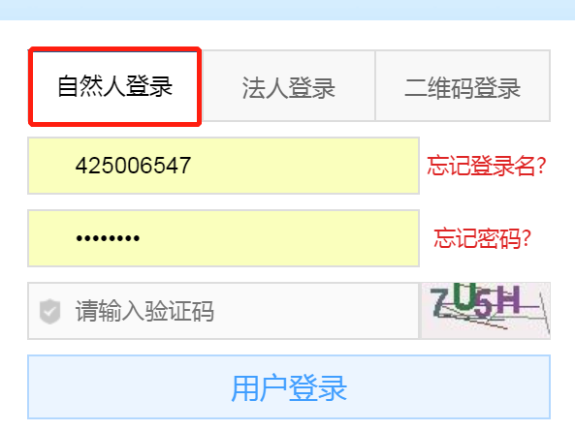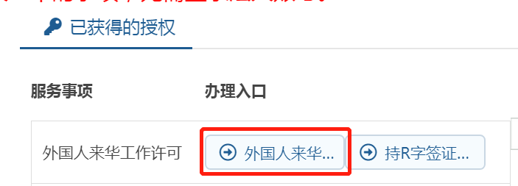
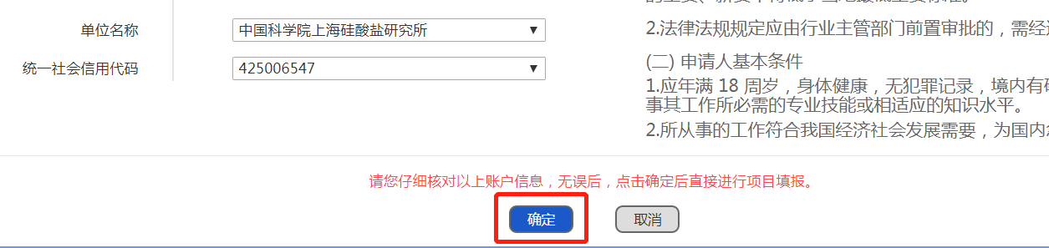
后续持相关签证来华，每次需登录系统更新来华信息。
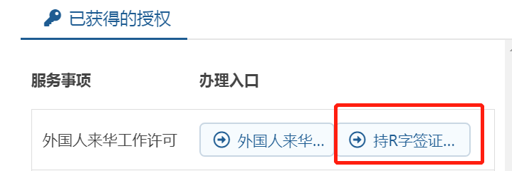
- 简历：学习经历（高中起），工作经历（全职，提供工作证明），文章等列表
CV, Study and working experiences with accurate year and month, education background has to start from senior high school, working experiences information has to be coherent since graduation. Original copy of Proof of relevant working experience (full time role) including job description, working time, contact person’s telephone or e-mail, official seal or head signature. List of Papers, Publication and so on.
- 身份证件：最新的护照扫描件
Passport, digital version. Copy of ID page of the passport.
- 申请表
APPLICATION FORM
- 签证办理地点
Accurate address of Embassy/Consulate of China in your Country.
- 最高学位证书及认证材料 please prepare in advance
Original copy of highest academic degree and Certifications from Chinese Embassy or Consulates .
- 体检证明 please prepare in advance
Photocopy of Physical Exam Record with laboratory test report issued by the hospitals appointed or certified by Chinese Embassy or Consulates or Shanghai International Travel Healthcare Center within 6 months. Please bring all the original copies of your exam record when you come to China, including electrocardiogram, X-ray photograph and etc. All the documents mentioned above will be requested for your physical examination authentication in Shanghai International Travel Healthcare Center. Please see the examination form in the attachment.
- 与研究所签订的合同
Contract signed with SICCAS, please see the temple in attachment.
- 6个月内免冠照片
Recent soft copy of passport sized photos against white background.

- 申请R签证/Z签证来华
持《R签确认函/Z签工作许可通知》，至中国驻外大使馆自行申请R/Z签证。
With Confirmation Letter for High Level Foreign Talents to apply for R visa or Work Permit Notice for Z visa in Chinese embassies.
外国高端人才获得R字签证后，请注册持R字签证外国人入境信息更新系统（Entry Information Updating System for Foreigners with R Visa），并每次入境前及时更新相关信息，可能会对您以后入境工作产生影响。https://fuwu.most.gov.cn/
After obtaining a R Visa as foreign high-level personnel, you need to register with Entry Information Updating System for Foreigners with R Visa and update relevant information before each entry. Failure to do so may affect your future entry and work in China.

- 来华后临时住宿登记
- 提前预约，至人事处办理《入住通知单》，至保障办办理正式入住手续
- 电话咨询入住公寓所属派出所，至人事处索取《住宿证明》及其它材料，入境24小时内至派出所办理相关手续或网上申请https://crjzndg.gaj.sh.gov.cn/24hr/web/zcbd/login?relogin=true ；

- 博士后入职
- 博士后进站手续办理：http://www.sic.cas.cn/glbm/rlzyc/bshldz/lc/
- 博士后入职流程：http://nw.sic.ac.cn/Read.Asp?PPNewsID=3512

- 预约出入境体检
来华一周内，到上海出入境检验检疫局办理，上海市金浜路15号。
（电话预约： 62688851，网站预约：www.sithc.com）

- 工作许可办理
政策介绍：http://ftsh.sgst.cn/wzckgzd/
办理网址： https://fuwu.most.gov.cn/

- 居留许可办理（工作类）
https://gaj.sh.gov.cn/crj/homeZ

